Chapter 19, Solution 67.

We first the y parameters, To find y₁₁ and y₂₁ consider the circuit below.

I₁ 30 Ω 40 Ω I₂

+
1 A 10 Ω V₂ =0
V₁
-

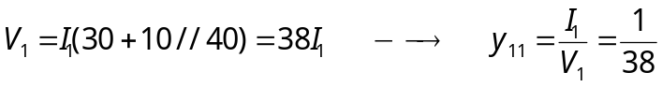
By current division,
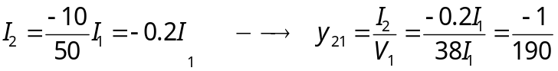
To find y₂₂ and y₁₂ consider the circuit below.

I₁ 30 Ω 40 Ω
I₂

+ +

V₁=0 10 Ω V₂ 1 A

- -

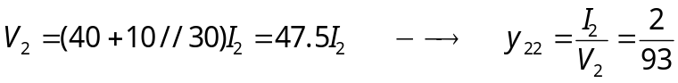y₂₂ = 2/95
By current division,
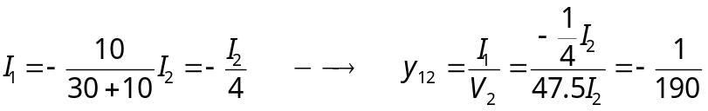

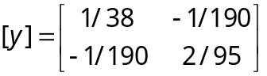

For three copies cascaded in parallel, we can use MATLAB.

>> Y=[1/38,-1/190;-1/190,2/95]
Y =
0.0263 -0.0053
-0.0053 0.0211
>> Y3=3*Y
Y3 =
0.0789 -0.0158
-0.0158 0.0632
>> DY=0.0789*0.0632-0.0158*0.158
DY =
0.0025
>> T=[0.0632/0.0158,1/0.0158;DY/0.0158,0.0789/0.0158]
T =
4.0000 63.2911
0.1576 4.9937

T = 